Brandon Eiler

Game Programming Year 1 2022/23

Task 5: Debugging Exercises

Exercise 1 & Exercise 4: Run the Debugger & Using the Debugger (image attached in folder)

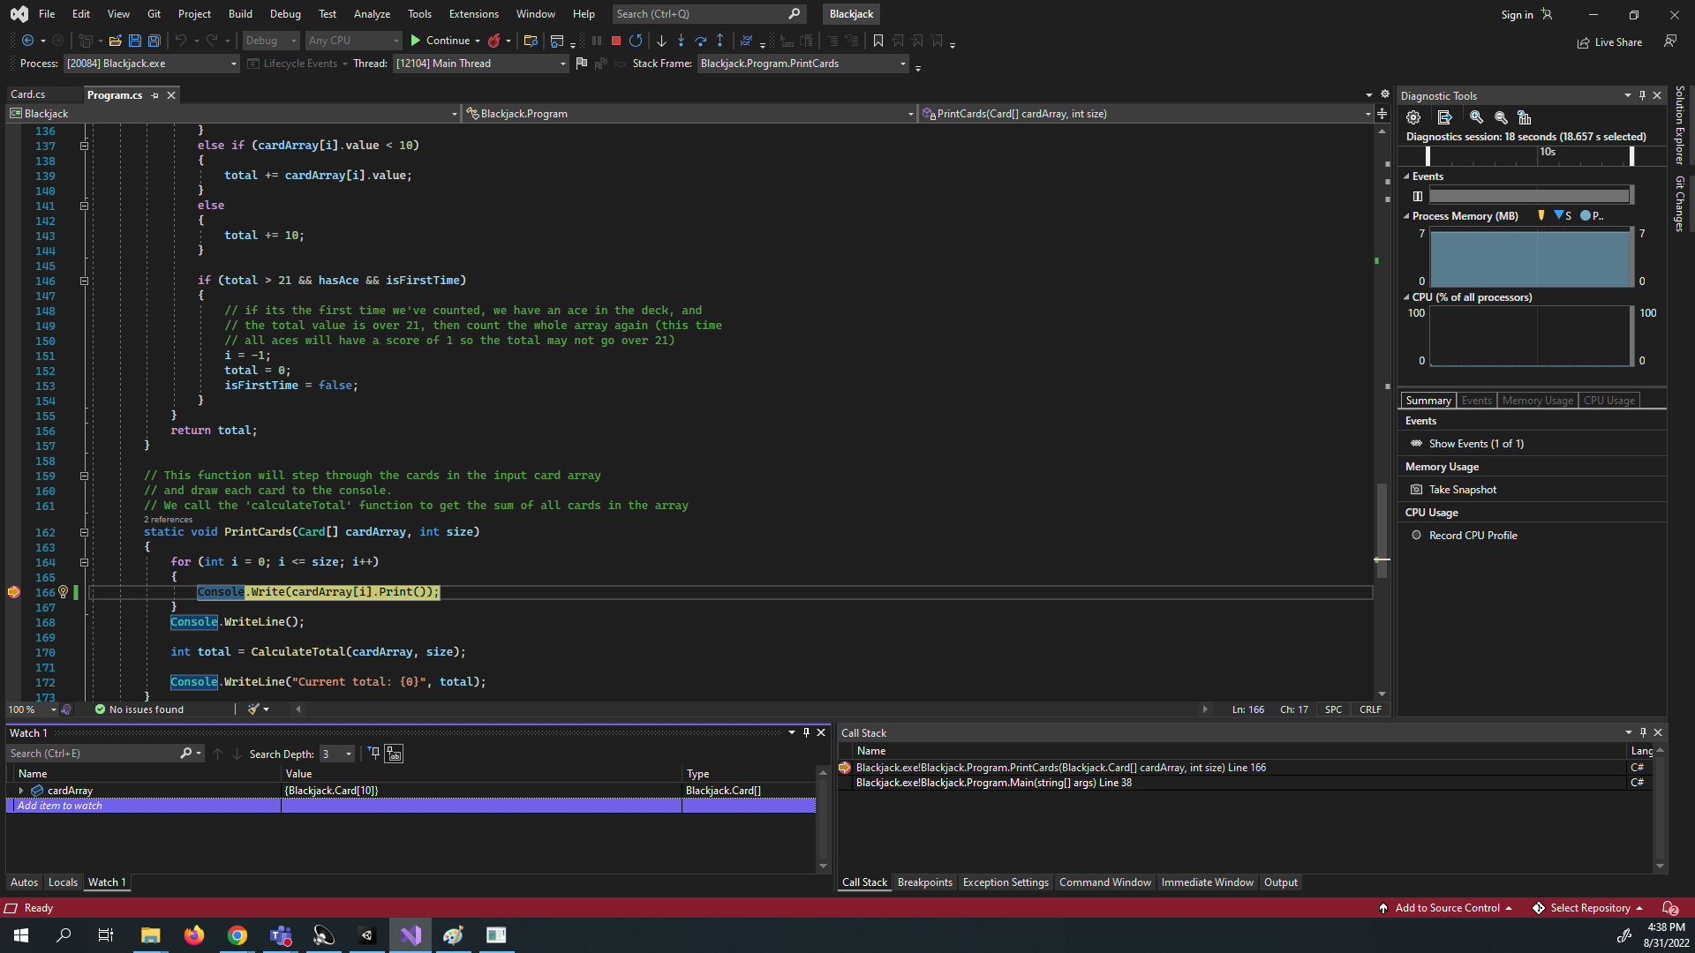

Exercise 2: Compiler Errors (images attached in folder)

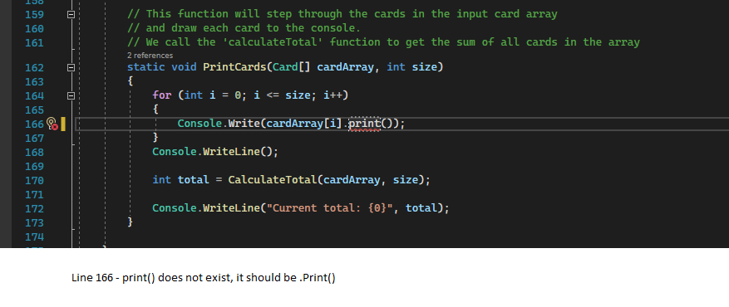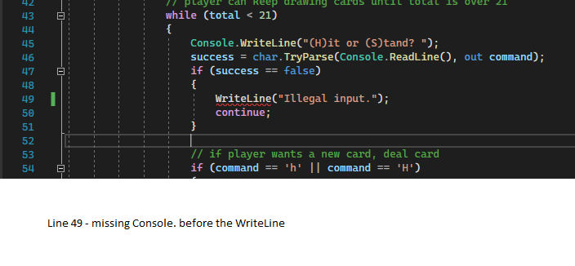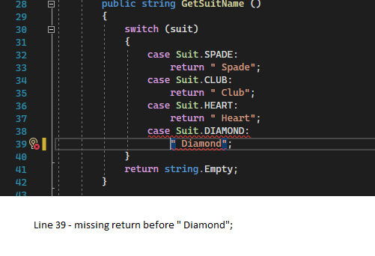

**Exercise 3: Reference Material**

Compiler error references: <https://docs.microsoft.com/en-us/dotnet/csharp/language-reference/compiler-messages/>

Language references: <https://docs.microsoft.com/en-us/dotnet/csharp/language-reference/>

Other programming reference: <https://www.geeksforgeeks.org/analysis-algorithms-big-o-analysis/>